Contents

Overview 1

Change History 1

Getting events to appear in the About Niem Events page 2

Getting events to appear in the "MyNIEM" News/Events tab 5

Adding the New Event option to the Bamboo Calendar Plus Web Part 7

Adding the “(C) CZ Calendar” content type to a SharePoint calendar to allow for rollups 15

# Overview

The intention of this document is to document how to use the Bamboo **Calendar Plus Web Part** to reflect two forms of calendar rollup information. The first form of rollup is having an instance of the Bamboo **Calendar Plus Web Part** show all listitems from SharePoint Calendars that are using the “(C) CZ Calendar” content type with list items of that type marked as **Public.** The second form of rollup consists of using the Bamboo **Calendar Plus Web Part** to show data specifically pulled from lists and libraries listed within the Bamboo **Calendar Plus Web Part** properties.

# Change History

|  |  |  |
| --- | --- | --- |
| Modified By | Modified On | Change |
| Rick Snyder (LCG) | 07/25/2013 | Created document |

# Getting events to appear in the About Niem Events page

The [About Niem Events](https://www.niem.gov/aboutniem/events/Pages/events.aspx%20calendar) page contains a Bamboo **Calendar Plus Web Part**. This web part is configured to use the **Bamboo Solutions List Rollup** as the data source and a list rollup schema of type **CZ Calendar Schema**. This means that the Bamboo **Calendar Plus Web Part** will look at the lists in the site collection that you are allowed to access and show the the list items found that have a content type “[(C) CZ Calendar](https://www.niem.gov/_layouts/ManageContentType.aspx?List=%7B55CD8ABF%2DFCB9%2D47E1%2D80A5%2D7A6F68E3C3B9%7D&ctype=0x0102009463B980D1DCF74C871F7FC271FBF433008F90CC9237280C48BA834C799976D441)” and have the **Public** site column checked.

The following screen shots will illustrate how to add an item to a calendar so that it will on the [About Niem Events](https://www.niem.gov/aboutniem/events/Pages/events.aspx%20calendar) Bamboo **Calendar Plus Web Part**. First, we navigate to the Justice Calendar in the [Justice Workspace](https://www.niem.gov/communities/justice/justice-community/justice-workspace/SitePages/Home.aspx) site. The Justice Calendar is configured to use the “[(C) CZ Calendar](https://www.niem.gov/_layouts/ManageContentType.aspx?List=%7B55CD8ABF%2DFCB9%2D47E1%2D80A5%2D7A6F68E3C3B9%7D&ctype=0x0102009463B980D1DCF74C871F7FC271FBF433008F90CC9237280C48BA834C799976D441)” as the default content type. The next step is to add a new item which will open up the popup shown below. You must select the **Public** check box on the New Item/Edit Item popup window so that this item will appear in the Bamboo **Calendar Plus Web Part** on the [About Niem Events](https://www.niem.gov/aboutniem/events/Pages/events.aspx%20calendar) page

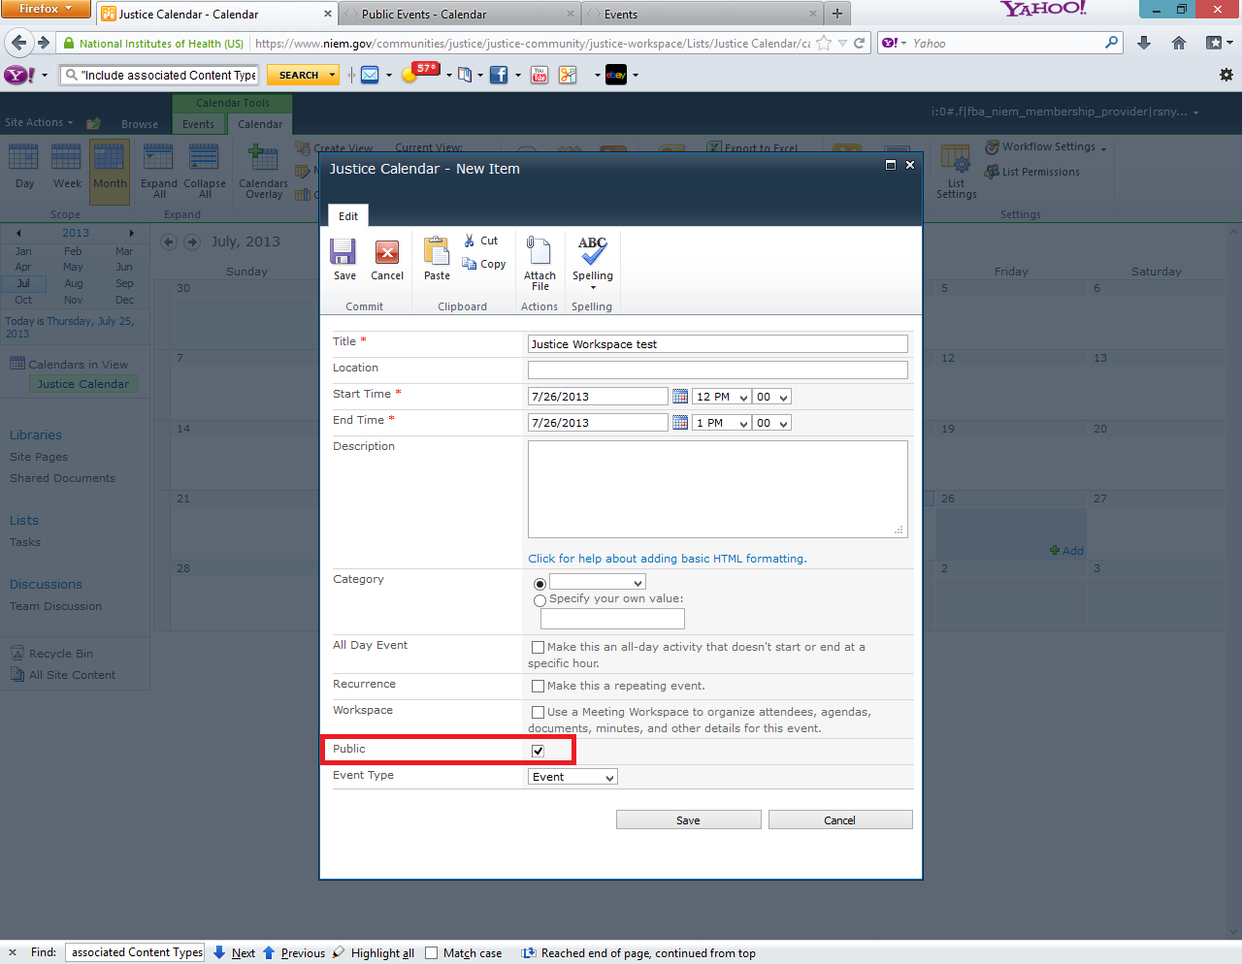

Once you save that item, it will appear in the Bamboo **Calendar Plus Web Part** on the[About Niem Events](https://www.niem.gov/aboutniem/events/Pages/events.aspx%20calendar) page.

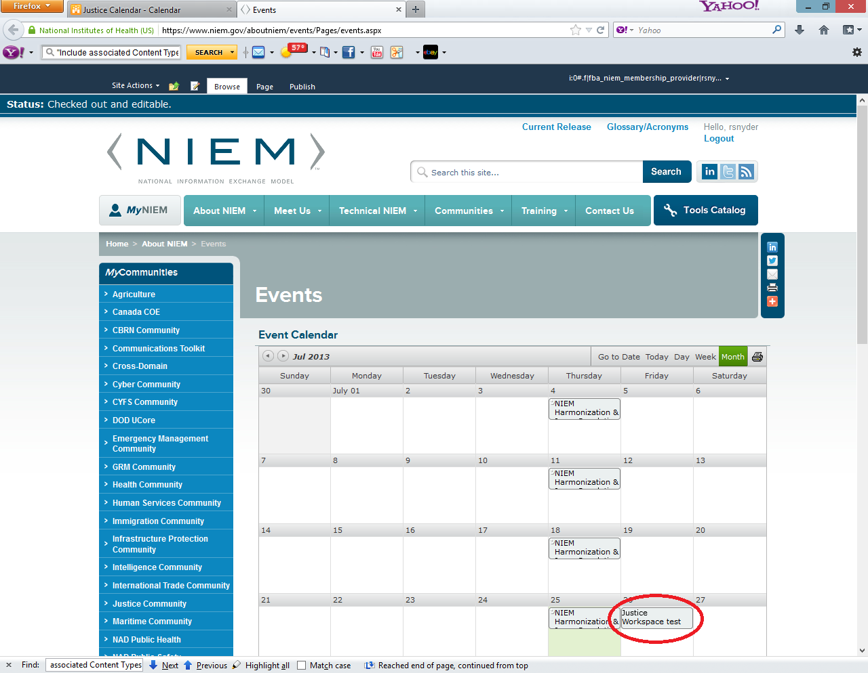

Now, the Bamboo **Calendar Plus Web Part** is security sensitive so it will only show the items that you have access to view even though you have the item be marked as public. So, in our example, if I do not have access to the [Justice Workspace](https://www.niem.gov/communities/justice/justice-community/justice-workspace/SitePages/Home.aspx) site, then I will not see those public events listed as shown here.

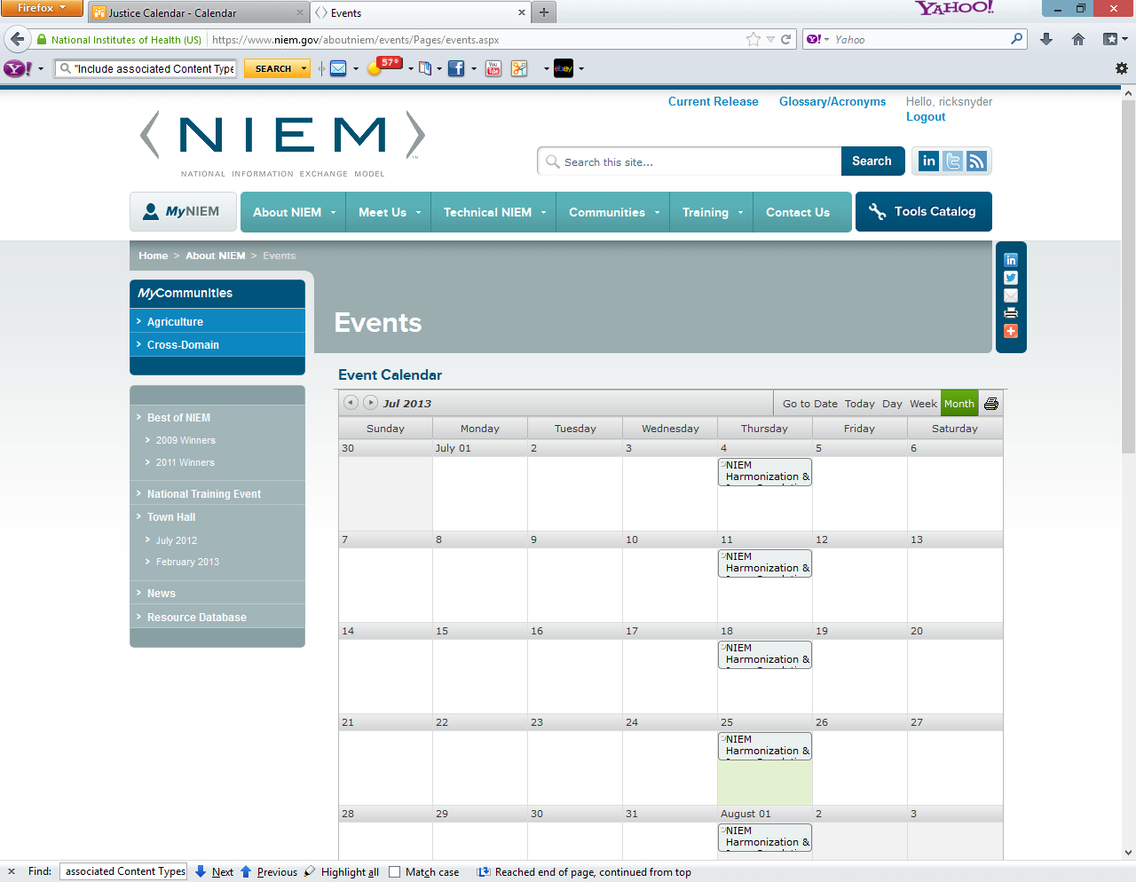

# Getting events to appear in the "MyNIEM" News/Events tab

This works in a similar fashion as it does to get an event to appear in the Bamboo **Calendar Plus Web Part** on the [About Niem Events](https://www.niem.gov/aboutniem/events/Pages/events.aspx%20calendar) page. You add a new item with the content type of “(C) CZ Calendar” a SharePoint calendar except you do not have to mark the event as **Public.**

In this example, I have open a list item from the Justice Calendar in the [Justice Workspace](https://www.niem.gov/communities/justice/justice-community/justice-workspace/SitePages/Home.aspx) site. I do have have the **Public** site column selected.

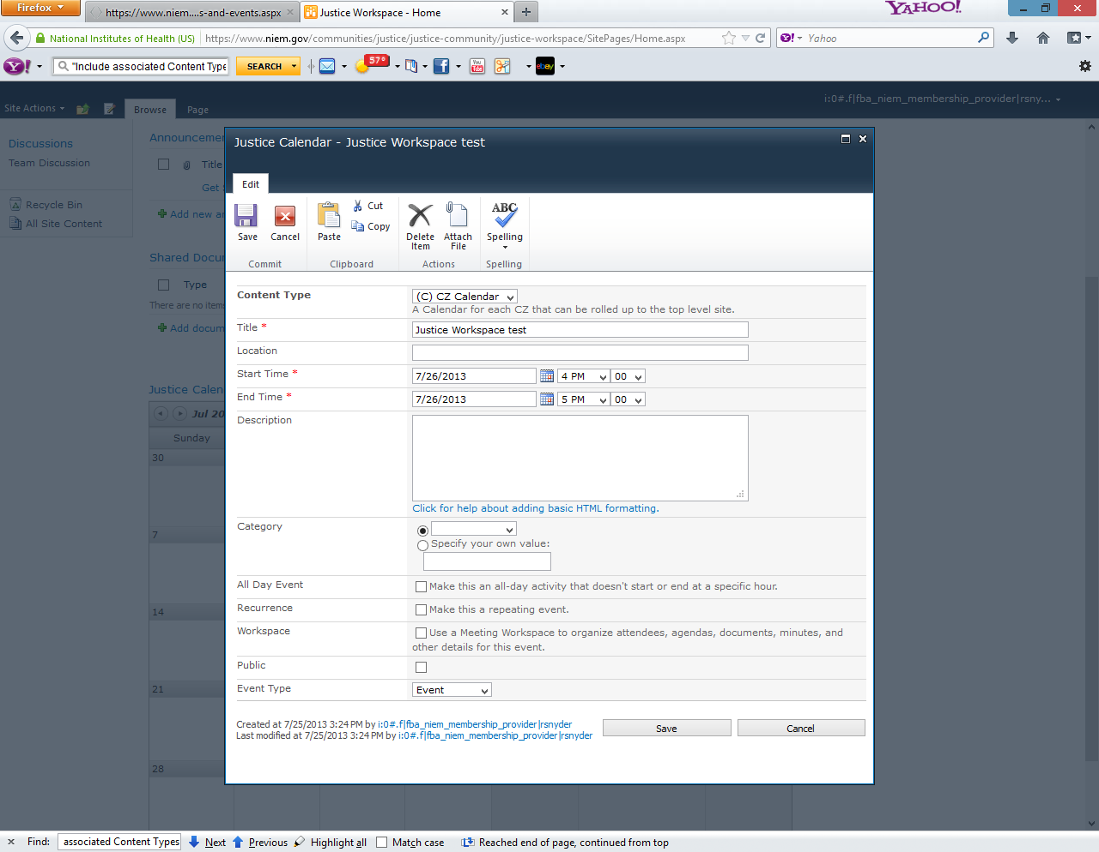

However, the item does appear on the News/Events tab within MyNiem.

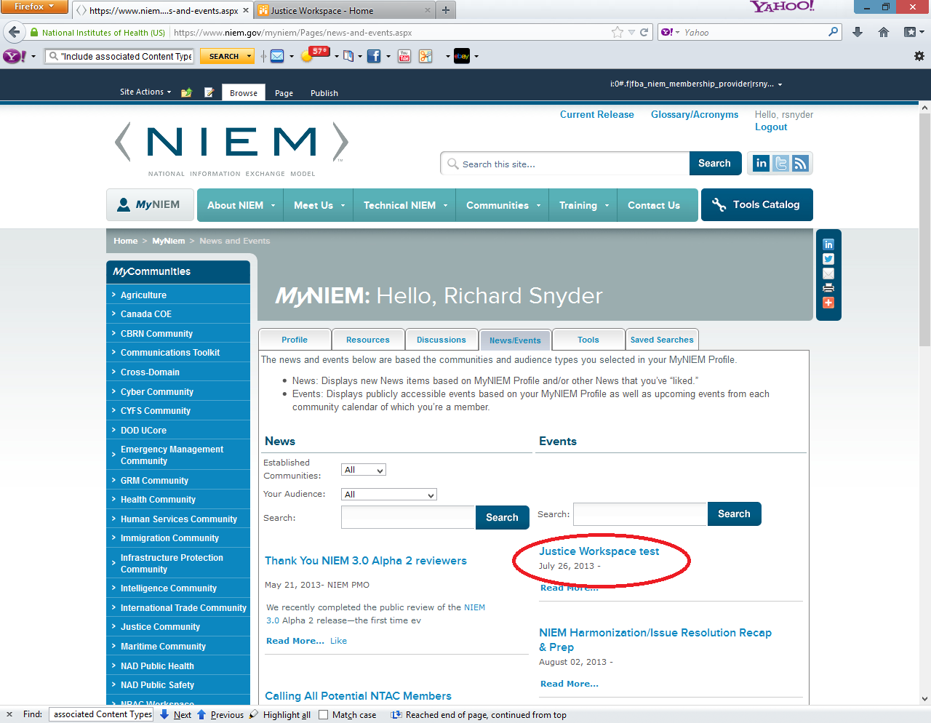

# Adding the New Event option to the Bamboo Calendar Plus Web Part

The landing page to the [Justice Community Workspace](https://www.niem.gov/communities/justice/justice-community/justice-workspace/SitePages/Home.aspx) site also contains a Bamboo **Calendar Plus Web Part.** This instance of the **Calendar Plus Web Part** has itsdata source type is set to “SharePoint Lists and Libraries”. Therefore, the contents shown in the web part are based on the lists and libraries that are listed in the **SharePoint List and Library** section of the web part properties.

The following screen shots will walk you through enabling the “New Item” option to the **Calendar Plus Web Part**. I will use the [Justice Community Workspace](https://www.niem.gov/communities/justice/justice-community/justice-workspace/SitePages/Home.aspx) to document this process. First, you need to edit the web part so you can access the web part properties panel

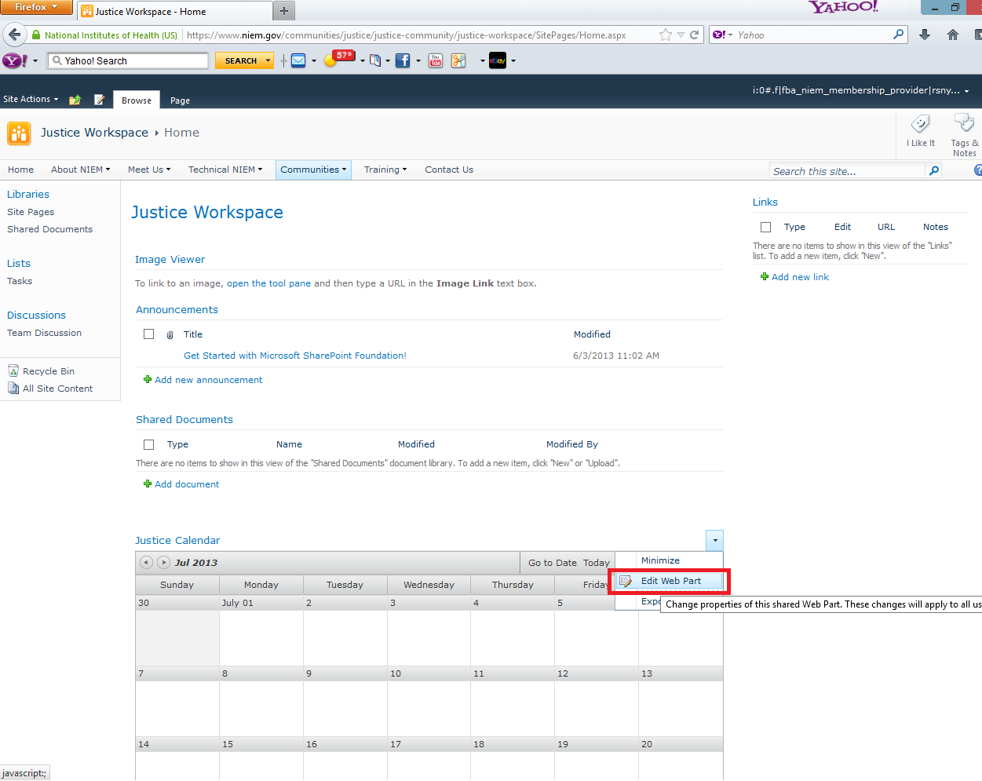

Next, click on the **Calendar Plus Web Part Settings** button in the web part properties panel.

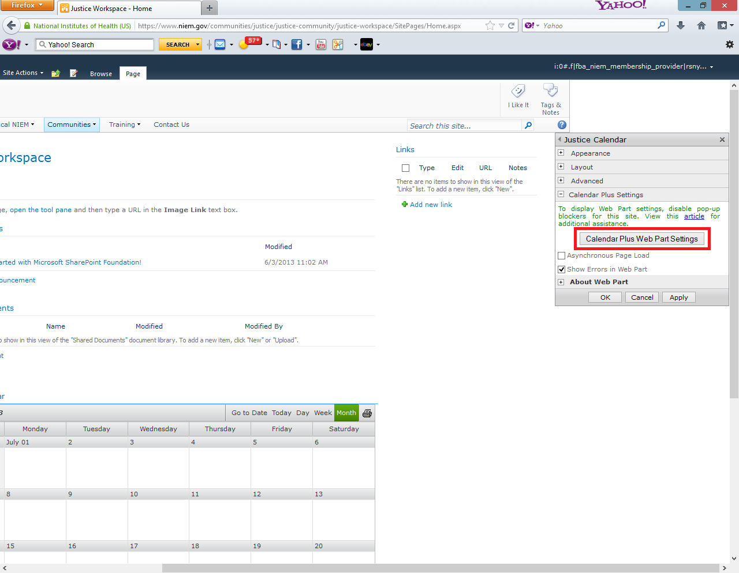

Click on **SharePoint List and Library** button in the left hand pane and the right hand pane will refresh to show the lists and libraries being displayed in the calendar web part. The web part on the **Justice Community Workspace** langin page is only showing information from 1 list and they do not have it set so a user can add new items. To enable a user to Add new items, click on the icon in the **Edit/View** icon to change this setting.

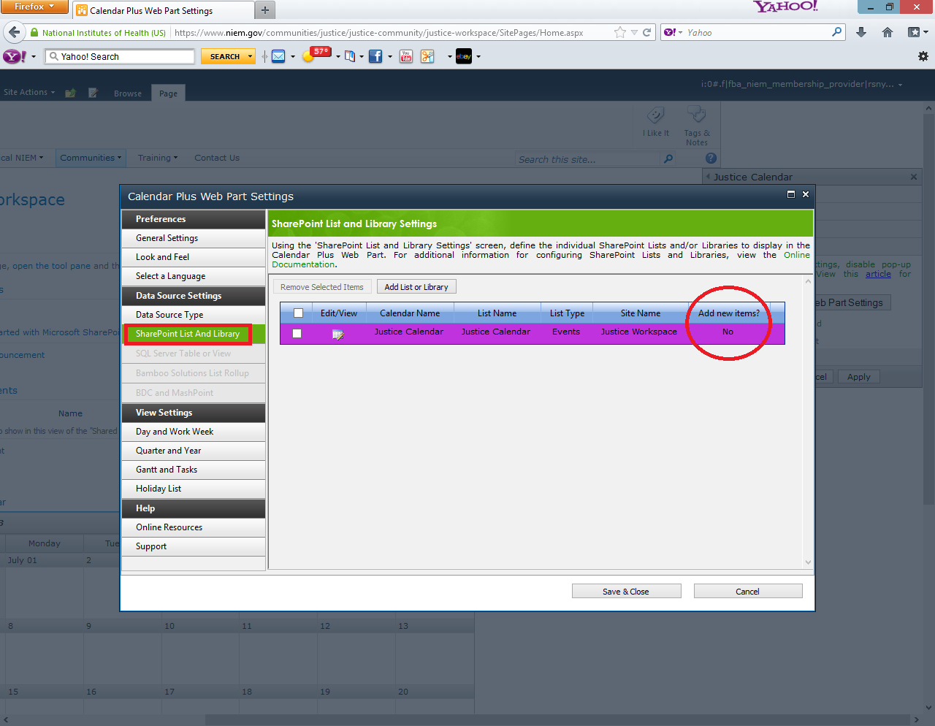

The details for the selected list will appear in a new popup window. On this window, you will need to check the **Allow users to add new items to the selected SharePoint List or Library**.Then a second check box will appear, **Include associated Content Types**, which you can also select. Finally, click on the **Save & Close** button to close this popup window to save these changes

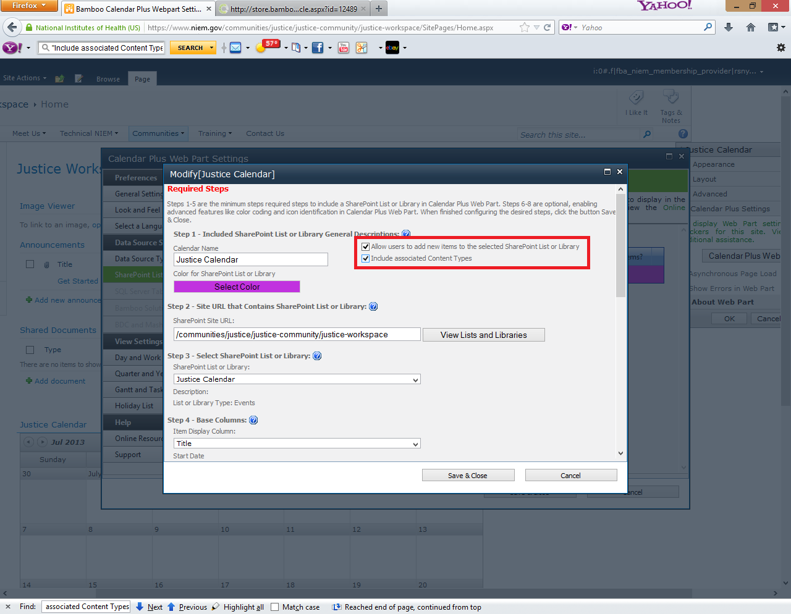

You will be returned to the **Calendar Plus Web Part Settings** popup. You will see the value in the **Add new items** column is now Yes. Click on the **Save & Close** button to close this popup.

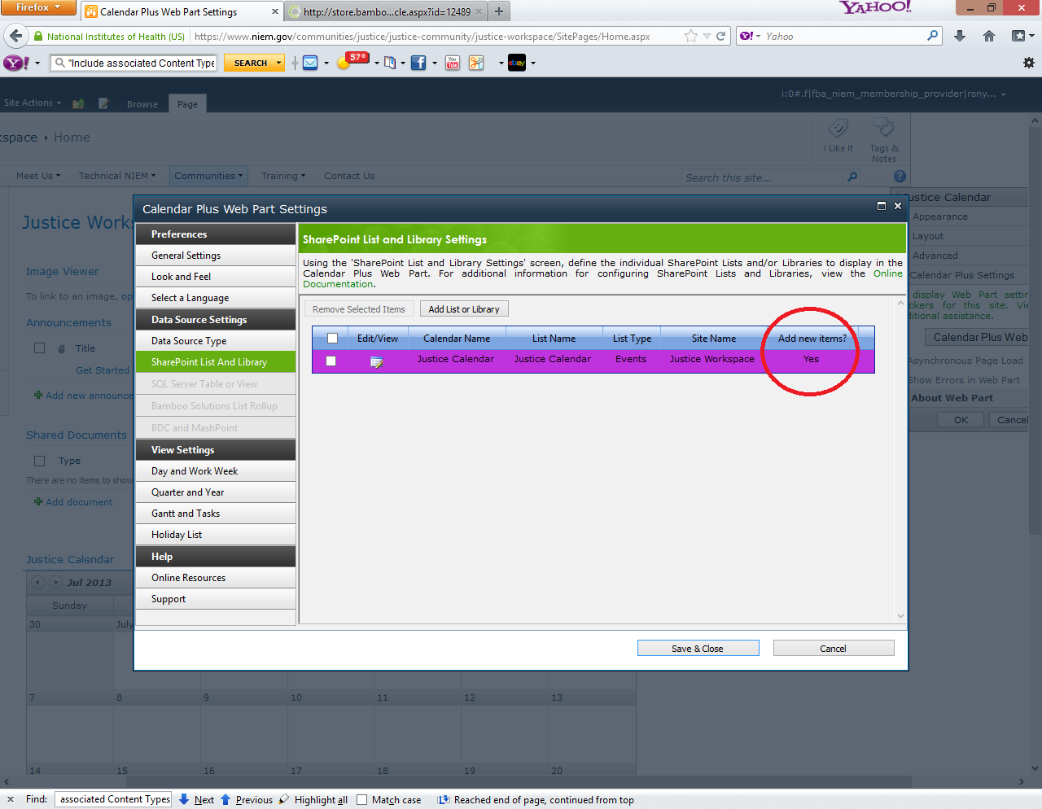

Finally, click on the **Ok** button in the web part properties panel to commit this change.

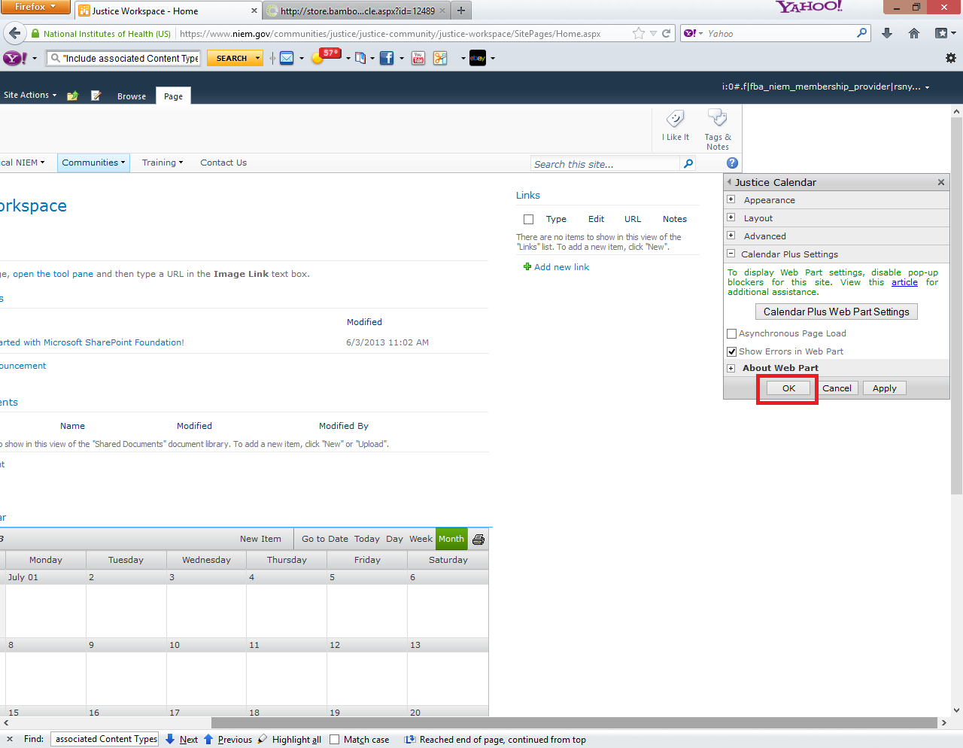

The Bamboo Rollup Calendar web part now has a **New Item** button exposed in the control. If you move your mouse over the New Item button, a drop down will appear that will show the calendars to which you are allowed to add new items.

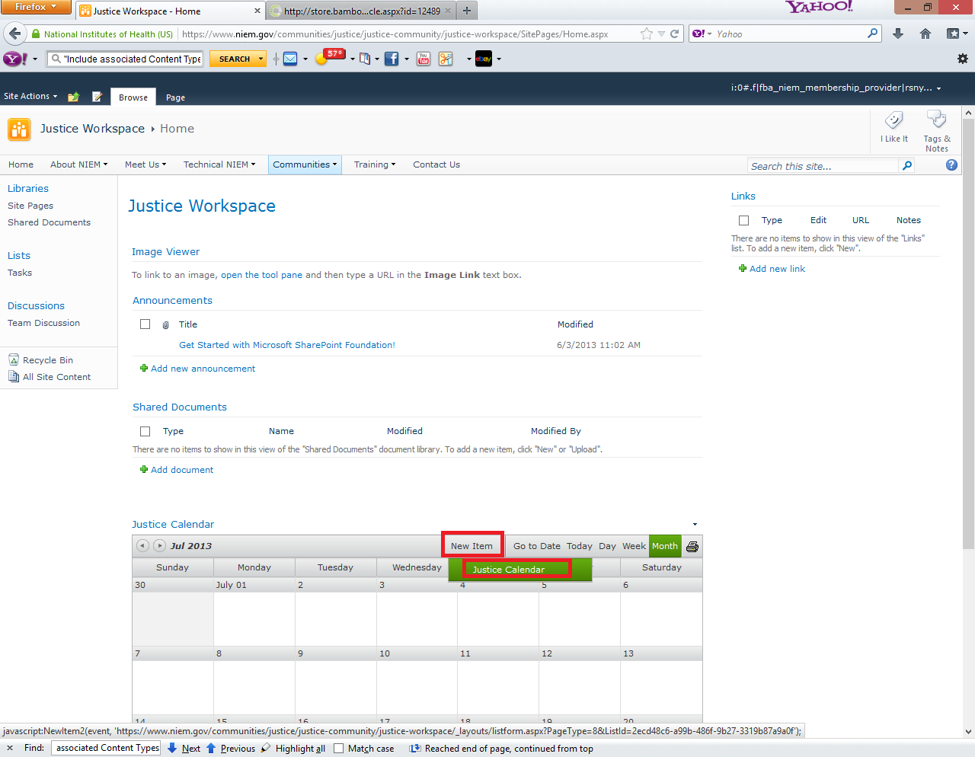

When you click on the calendar in that menu, you will see that calendar’s new item popup window appear. Here is the example for the **Justice Calendar**.

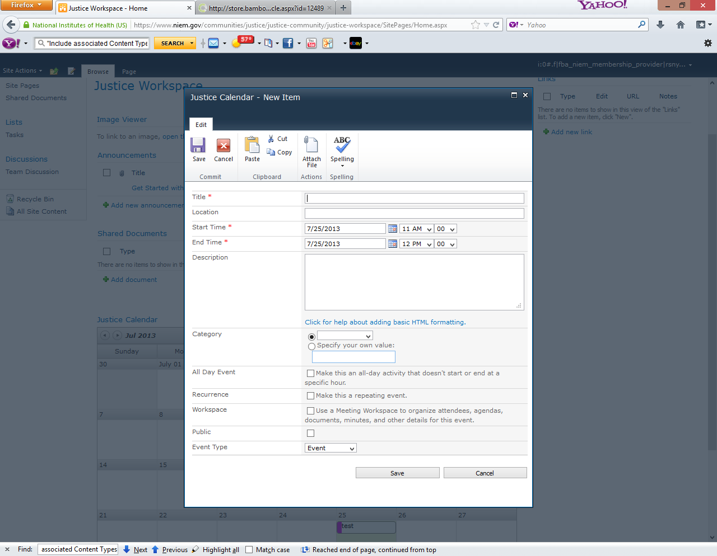

# Adding the “[(C) CZ Calendar](https://www.niem.gov/_layouts/ManageContentType.aspx?List=%7B55CD8ABF%2DFCB9%2D47E1%2D80A5%2D7A6F68E3C3B9%7D&ctype=0x0102009463B980D1DCF74C871F7FC271FBF433008F90CC9237280C48BA834C799976D441)” content type to a SharePoint calendar to allow for rollups

The Bamboo **Calendar Plus Web Part** can be configured with a data source of **Bamboo Solutions List Rollup** and a list rollup schema of type **CZ Calendar Schema**. This is how the calendar on the [About Niem Events](https://www.niem.gov/aboutniem/events/Pages/events.aspx%20calendar) page is setup. A standard SharePoint Calendar will uses the Event content type for the listitems. Therefore, you need to add “[(C) CZ Calendar](https://www.niem.gov/_layouts/ManageContentType.aspx?List=%7B55CD8ABF%2DFCB9%2D47E1%2D80A5%2D7A6F68E3C3B9%7D&ctype=0x0102009463B980D1DCF74C871F7FC271FBF433008F90CC9237280C48BA834C799976D441)” content type to a SharePoint calendar and set it as the default content type.

We will use the calendar in the [Justice Workspace](https://www.niem.gov/communities/justice/justice-community/justice-workspace/SitePages/Home.aspx) site to document this process. The calendar in the **Justice Workspace** site is called **Justice Calendar**. We need to open the list settings, so we click on the **Calendar** tab in the ribbon and then **List Settings**.

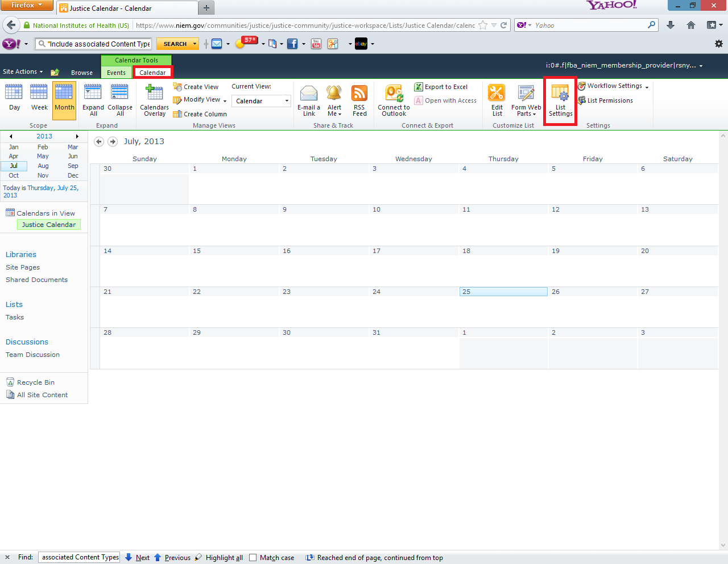

This is the list settings page. The “[(C) CZ Calendar](https://www.niem.gov/_layouts/ManageContentType.aspx?List=%7B55CD8ABF%2DFCB9%2D47E1%2D80A5%2D7A6F68E3C3B9%7D&ctype=0x0102009463B980D1DCF74C871F7FC271FBF433008F90CC9237280C48BA834C799976D441)” content type is already present as the default content type for this list. If it were not, then it would be matter of clicking on the **Add from existing site content types** and selecting that content type.

